**WEEK-2**

**JUnit Testing Exercises**

**Exercise 1: Setting Up Junit**

**CODE:**

**Step1:**

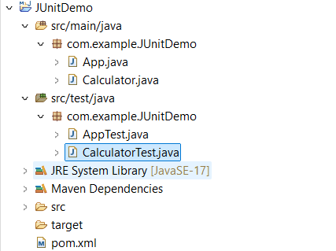

**Step 2:**

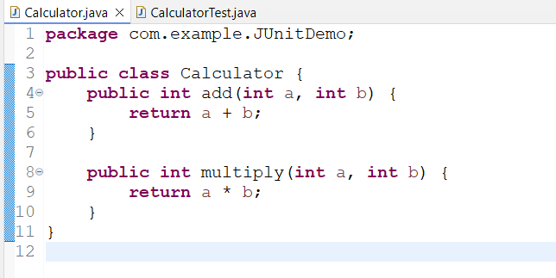

**Step 3:**

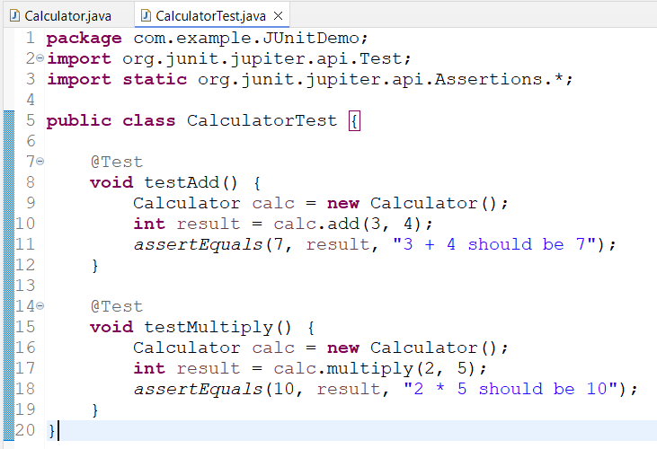

**Output:**

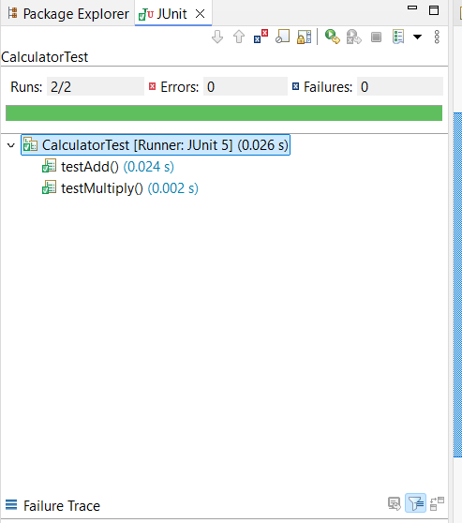

**Exercise 3: Assertions in Junit**

**Step1:**

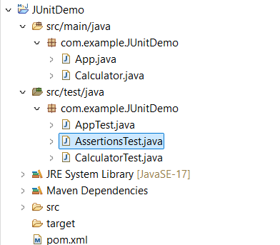

**CODE:**

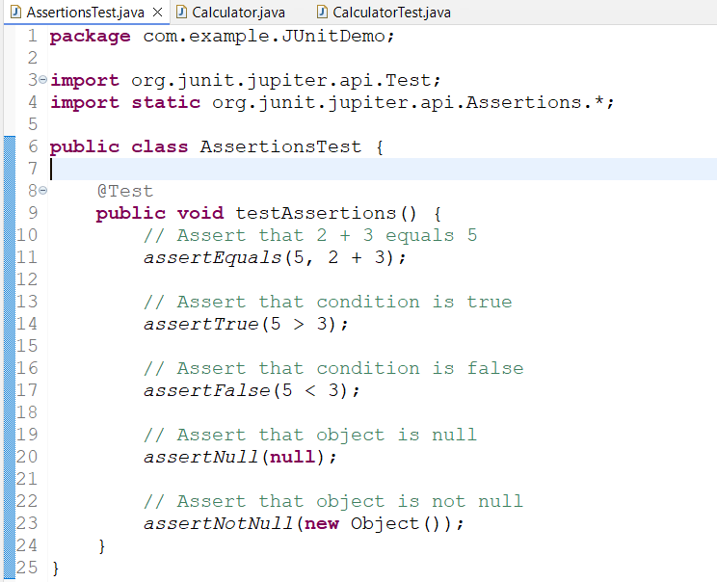

**Output:**

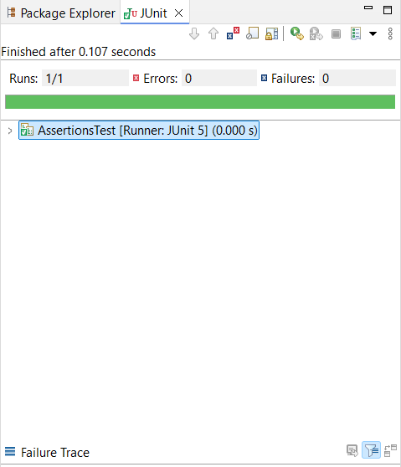

**Exercise 4: Arrange-Act-Assert (AAA) Pattern, Test Fixtures, Setup and Teardown Methods in Junit**

**Solution:**

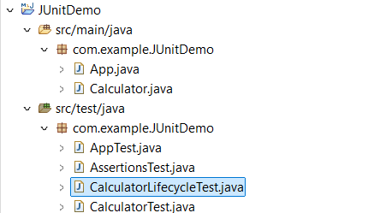

**Step 1:**

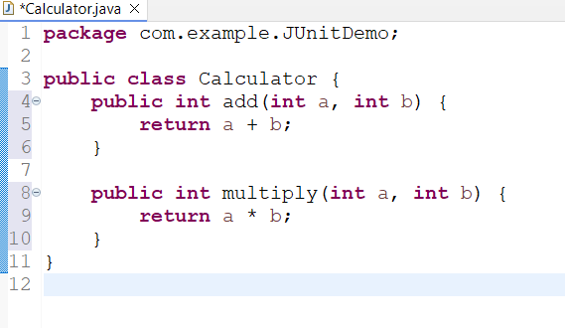

**Step 2:**

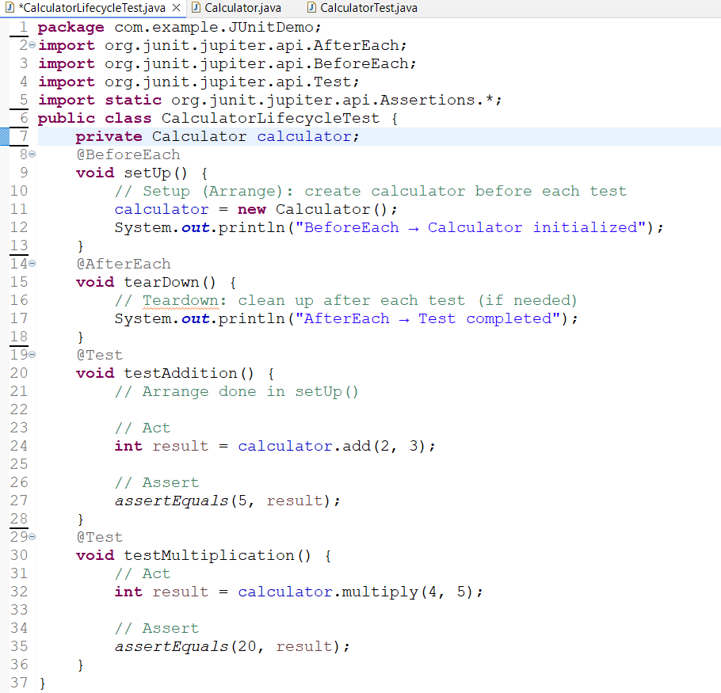

**Output:**

